**Reporting in VS2012**

* **Clicked on new project and there is a reporting application**

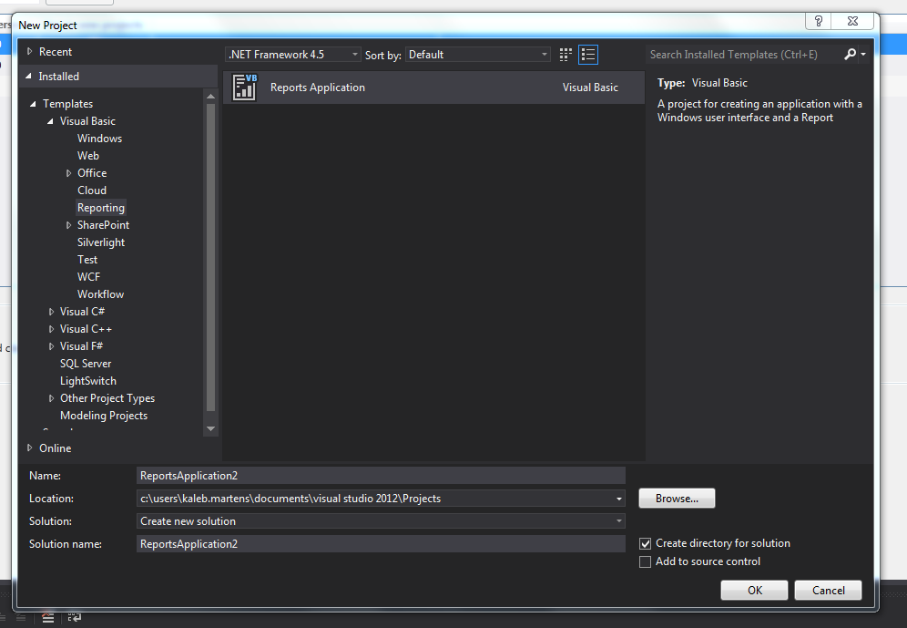

* **Choose a data connection (SQL, access etc.) I chose my IS 166 access database**

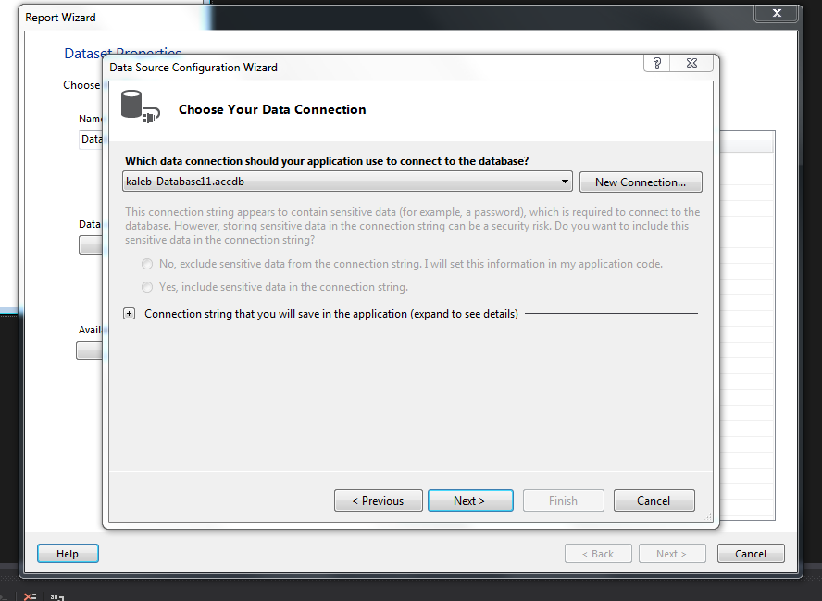

* **Choose your objects**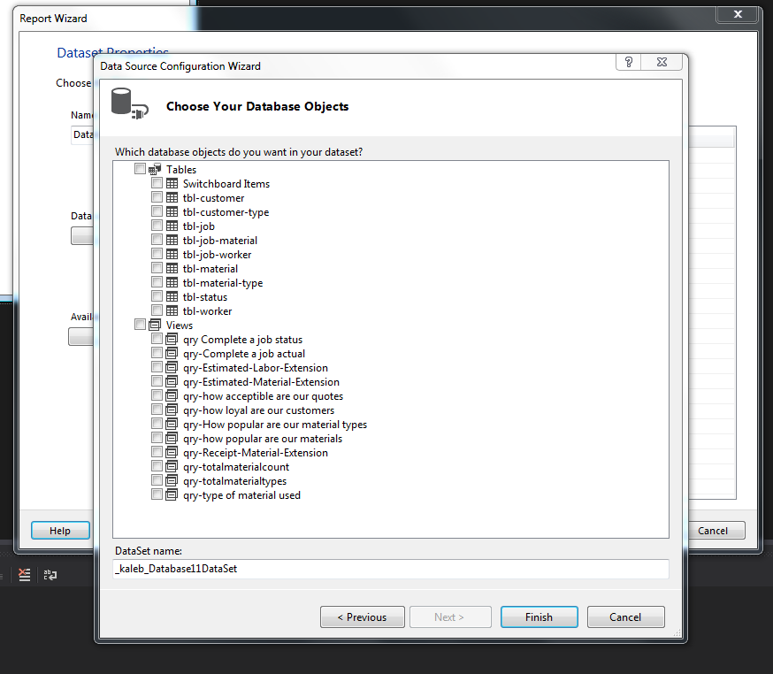
* **There is the report screen**
* **Not sure how we can implement this into lightswitch**

